**Alten Challenge solution**

**Technologies**

* Java
* Spring boot
* maven
* H2
* Junit
* Eclipse
* GitHub
* AWS
* Circle CI
* Travis CI

**Database structure**

* Vehicle entity
  + ID
  + VEHICLE_ID
  + REG_NO
  + STATUS
* Customer entity
  + ID
  + NAME
  + ADDRESS
* Relation is many-to-many

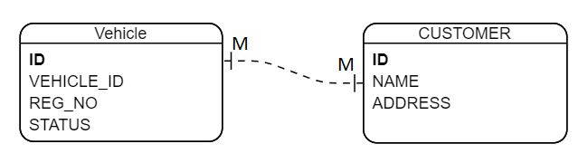

**Run the solution**

* Clone the repo   
  git clone https://github.com/michaelsamirg/alten_challenge.git
* Run command mvn spring-boot:run
* open [http://localhost:8080](http://localhost:8080/)

**Test the solution**

* Run command mvn test

**CI verification**

* Circle

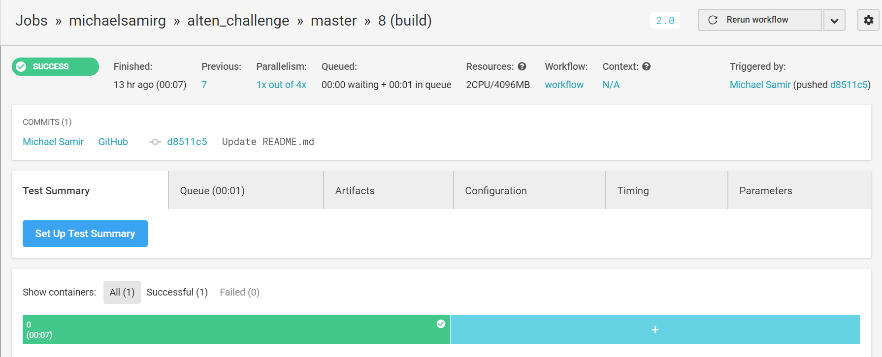

* Travis

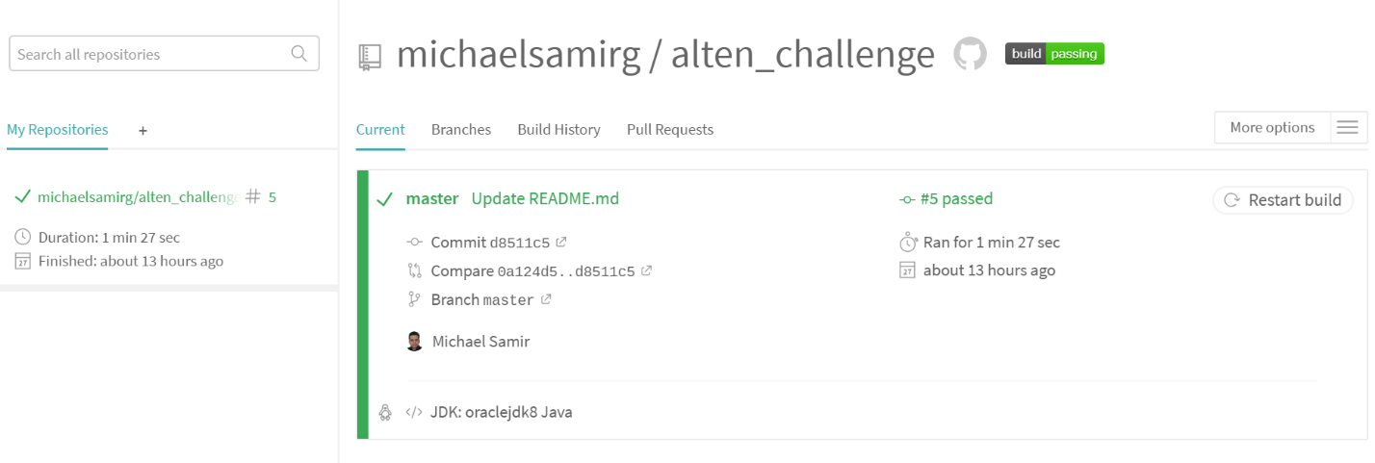

**AWS deployment**

* Using EC2 instance
* Deployed the application on the instance using UNIX service
* Access the application online here: <http://3.18.18.7:8080/>

